Let's Celebrate!
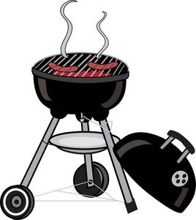

Conneaut Friday Night Group
Annual Picnic

Amboy Methodist Church
554 West Main Road
Conneaut OH, 44030

June 19, 2026

Fellowship Starts at 6:00PM
Food at 6:30PM

Speaker Tim C., South Dayton, NY
at 7:30PM

Hamburgers/Hot Dogs & Beverages (Water/Coffee/Soda) Provided
Please Bring Something To Share

50/50 and 7th Tradition will be donated to our District!

